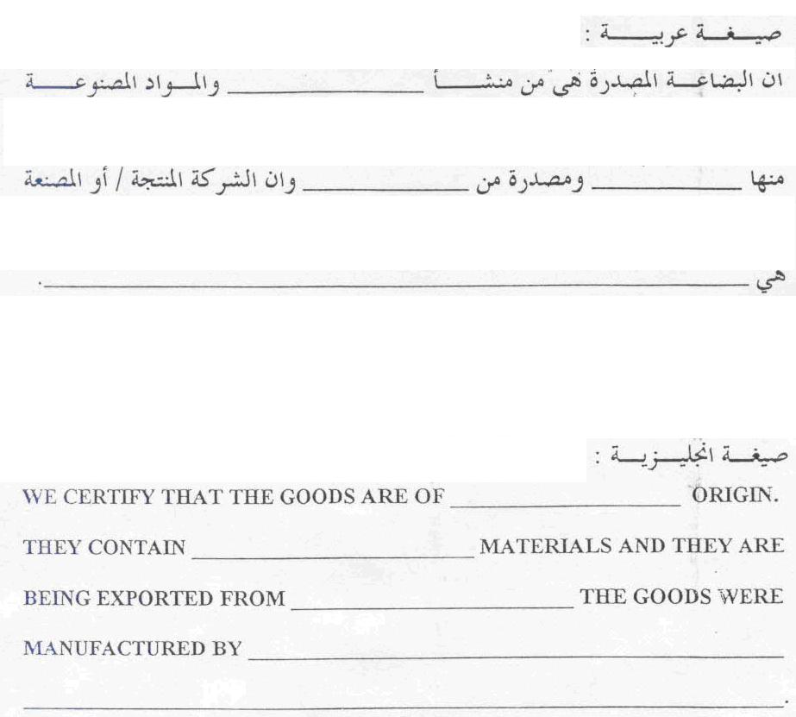 |  | CHINA
 | CHINESE

